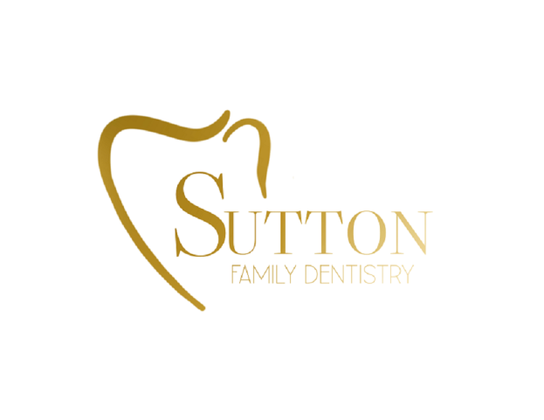
Dental Records Release Form

Patient Name to transfer: ______________________________________________________

Date of Birth: ______________________________________________________________

Other family members to transfer: ________________________________________________
________________________________________________________________________

Please release dental records (including clinical notes, treatment plans, and most recent x-rays) for the patient(s) listed above to the following office:

Sutton Family Dentistry
715 East Eldridge Avenue Wynne, AR 72396
Phone: 870.238.3628
Email: jsuttonfamilydentistry@gmail.com

I hereby give permission to release all dental records, including x-rays, charting, and photographs to the dental provider listed above.

Patient/Parent (Guardian) Signature: ______________________________________________

Date:_____________________________________________________________________

